 | PES University, Bengaluru-85  (Established under Karnataka Act No. 16 of 2013) | UE18MA251
MAY 2020: MODEL ESA PAPER, B.TECH, IV-SEMESTER

UE18MA251 – LINEAR ALGEBRA AND ITS APPLICATIONS
SCHEME AND SOLUTION

 | Time: 03 Hours Answer All Questions Max Marks: 100
1 |  | a) | Do the lines x–4y=1, 2x–y=–3 and –x–3y=4 have a common point of intersection? Explain with a diagram.  Consider the equation x–4y=1  Let x=0 ; y = –1/4 ; Let y=0 ; x=1  The corresponding points are ( 0, –1/4 ) and (1,0) 1 mark  Consider the equation 2x–y=–3  Let x=0 ; y = 3 ; Let y=0 ; x=–3/2  The corresponding points are ( 0, 3 ) and (-3/2,0) 1 mark  Consider the equation –x–3y=4  Let x=0 ; y = -4/3 ; Let y=0 ; x=–4  The corresponding points are ( 0, -4/3 ) and (-4,0) 1 mark  Draw the Graph 2 marks  Therefore, the common point of intersection is (-13/7 , -5/7) 1 mark | 6
 |  | b) | Use Gauss Elimination to solve the following system of equations:  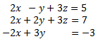 Each step 1 mark  The augmented matrix of the system is  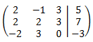  Subtract the first row to the second one and we add the third row with the first.  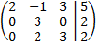  Multiply the first row by 1/2 and the second one by 1/3  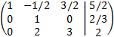  Add the first row with the second one multiplied by 1/2 and the third row with the second one multiplied by -2  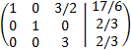  Multiply the third row by 1/3  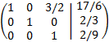  Add the first row with the third multiplied by -3/2  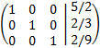  Using backward substitution, we get  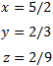 | 7
 |  | c) | Find the inverse of A = 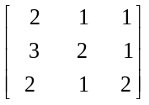using Gauss-Jordan method.  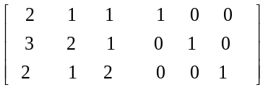 1 mark  R₁→R₁ – R₂  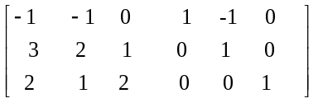 1 mark  R₁→- R₁ ; R₂→ R₂ +3R₃; R₃→R₃ +2R₁  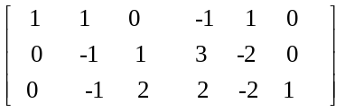 1.5 marks  R₁→ R₁ + R₂ ; R₂→- R₂; R₃→-R₃ –R₂  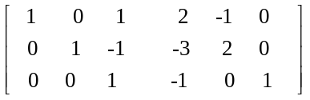 1.5 marks  R₁→ R₁ – R₃ ; R₂→R₂ +R₃  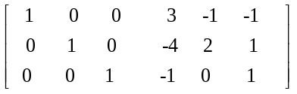1.5 marks  Therefore, Inverse of A is  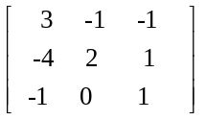0.5 mark | 7
2 |  | a) | Determine whether the given vectors (1, 1, 0), (0,2, 1) in R3 are linearly dependent or linearly independent .  Suppose we have scalars a and b such that  a.(1,1,0)+b.(0,2,1)=(0,0,0) 1 mark  Comparing the two sides requires a=0, a+2b=0, b=0,  which has only the solution 1 mark  a=b=0. 1 mark  Therefore the given vectors are linearly independent. 1 mark | 4
 |  | b) | Check whether the given polynomials 1+2t², 4+t+5t² and 3+2t are linearly dependent. Find the relationship if they are dependent.  Placing the given polynomials in a matrix we get  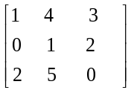 2 marks  R₃→R₃ – 2R₁  ~ 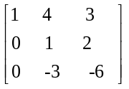 2 marks  R₃→R₃ + 3 R₂  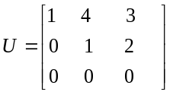 2 marks  R₁→R₁ – 4R₂  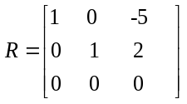 1 mark  Therefore P₃ = -5P₁ +2P₂ 1 mark | 8
 |  | c) | Find PA = LU factorization for the given matrix B. Verify the results.  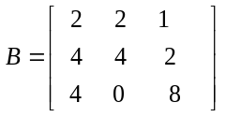  R₂-->R₂ -2 R_{1 ;} R₃→R₃ -2 R₁  ~ 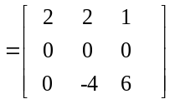 2 marks  Interchanging Row 2 and Row 3, we get  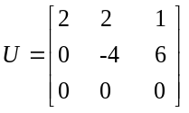 2 marks  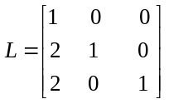2 marks  P₂₃ A = LU  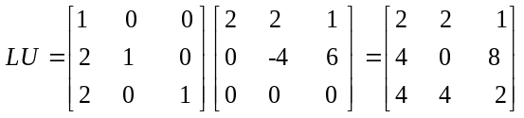 2 marks  Hence verified. | 8
3 |  | a) | Find the range and the kernel for the given linear transformations  - T(v₁, v₂, v₃) = (v₁, v₂, 0) ii) T(v₁, v₂, v₃) = (v₁, v₂) iii) T(v₁, v₂) = (0, 0)  - T(v₁, v₂, v₃) = (v₁, v₂, 0)  Range(T) = x-y plane in R³ 2 marks  Ker(T) = z-axis in R³  - T(v₁, v₂, v₃) = (v₁, v₂)  Range(T) = entire R² 2 marks  Ker(T) = z-axis in R³  - T(v₁, v₂) = (0, 0)  Range(T) = origin in R² 2 marks  Ker(T) = entire R² | 6
 |  | b) | Find all vectors in R³ that are orthogonal to (1,1,1), (1, -1,0). Produce an orthonormal basis from these vectors.  A = 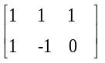  R₂→R₂ – R₁ Each step 1 mark  U = 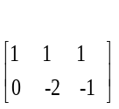  R₁→R₁ +1/2 R₂ ~ 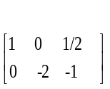  R = 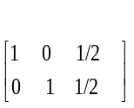  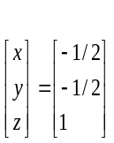  Basis for nullspace = {(-1/2, -1/2, 1)} = {(-1,-1,2)}  Basis for rowspace = {(1, 1, 1), (1, -1,0)}  Orthonormal Basis of rowspace =  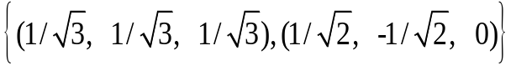 | 8
 |  | c) | Compute the projection matrix onto the line through a₁=(-1, 2, 2) and a₂=(2,2,-1).  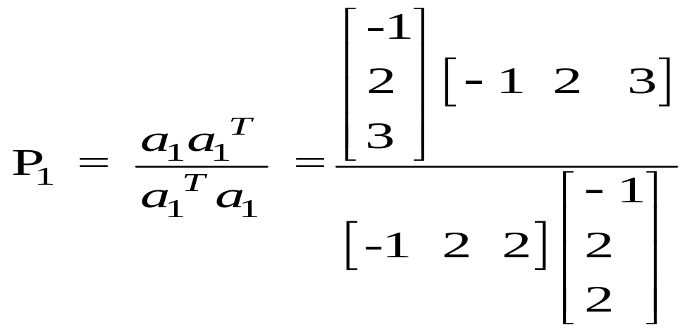 1 mark  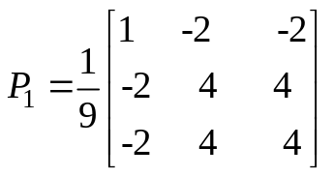 2 marks  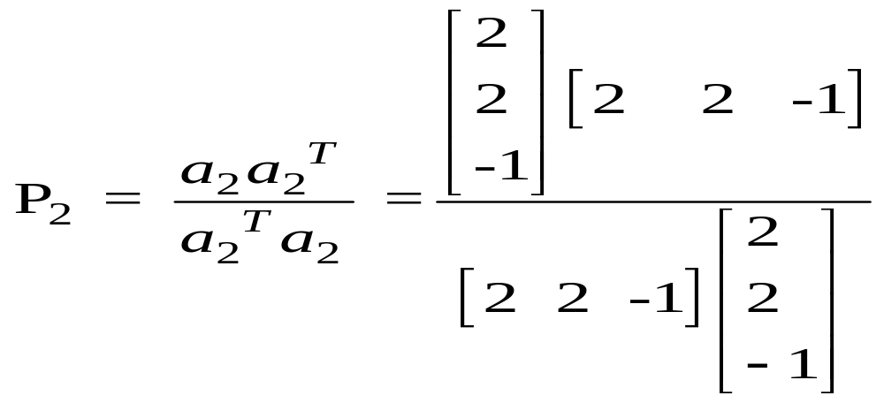 1 mark  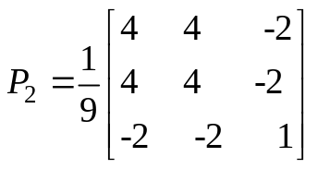 2 marks | 6
4 |  | a) | Use the Gram-Schmidt process to transform the basis .int0 an orthonormal basis for R³.  W₁ =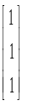 Each step carry 1 mark  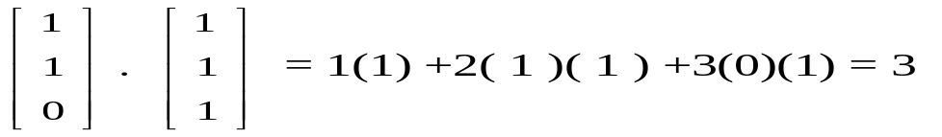.  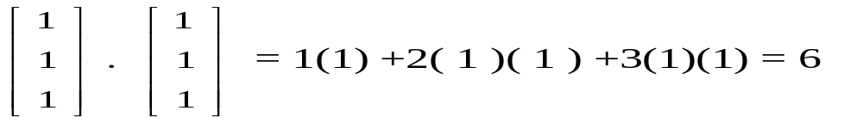    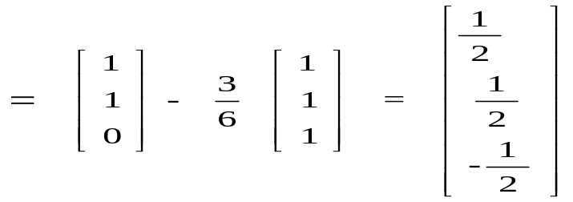  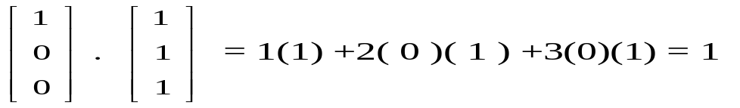  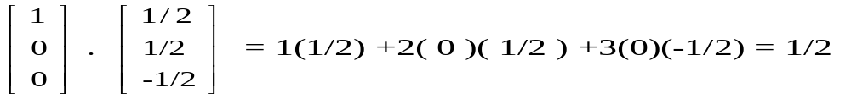  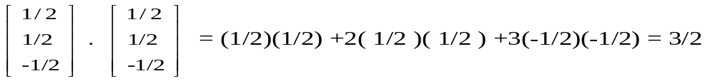  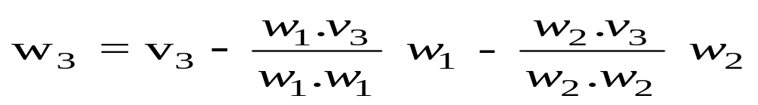  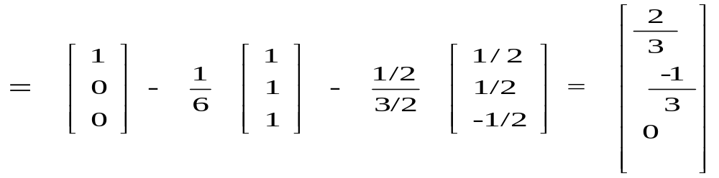  An orthogonal basis with respect to this inner product is  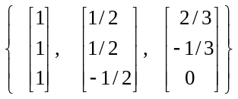  Normalizing with respect to this basis, we get an orthonormal basis  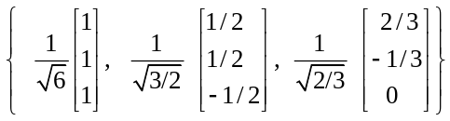 | 12
 |  | b) | Find the largest eigenvalue using power method for the given matrix A. Use (1, 0) as an initial approximation.  A = 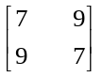  The eigenvalues of the given matrix A are 16, -2.  Given A = 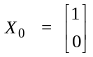  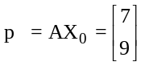  Largest eigenvalue is 9 1 mark  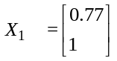  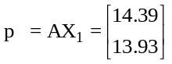  Largest eigenvalue is 14.39  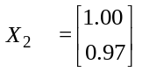  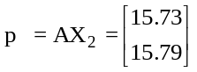  Largest eigenvalue is 15.79 2 marks  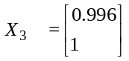  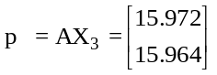  Largest eigenvalue is 15.972 2 marks  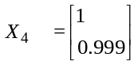  Largest eigenvalue is 15.972 1 mark | 8
5 |  | a) | Find the Singular Value Decomposition of  A = 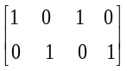  1 mark  AA^{T} = 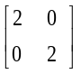  1 marks  A^{T}A =   The eigenvalues of AA^{T} are λ₁ = λ₂=2 1 mark  The matrix A has singular value σ₁= σ₂ = square root of 2. 1 mark  An orthonormal basis of eigenvectors of A A^{T} is . 1 mark  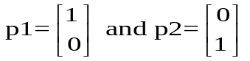  Therefore . 1 mark  P = 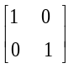  To find Q, use the formula  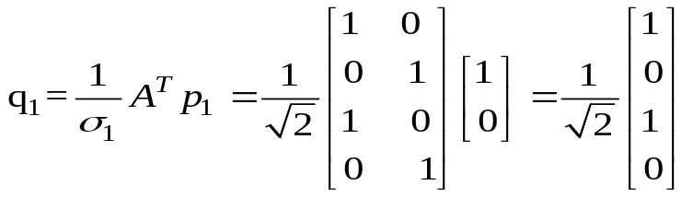 . 2 marks  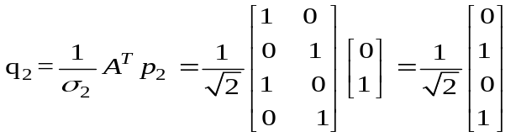. 2 marks  We choose q3 and q4 as  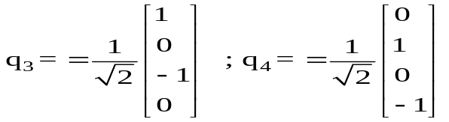 . 2 marks  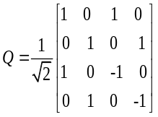  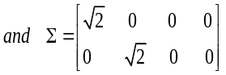. 2 marks | 14
 |  | b) | Define a positive definite matrix. Check whether the given matrix A is a positive definite or not.  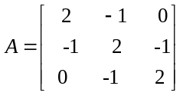.  A matrix is positive definite if it symmetric and all its pivots are positive.  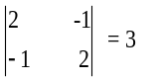  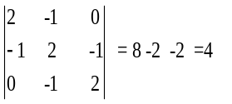  Since 2, 3, 4 >0, the given matrix A is a positive definite matrix. | 2+4

